ANOVA test

<https://www.analyticsvidhya.com/anova/>

### ANOVA (Analysis of Variance) Overview:

**Definition**:  
ANOVA is a statistical method used to determine whether there are significant differences between the means of three or more independent groups. It helps in understanding if at least one group mean is significantly different from the others.

ANOVA tests the null hypothesis that all group means are equal against the alternative hypothesis that at least one group mean is different.

### ****Types of ANOVA****:

**One-Way ANOVA**:

* 1. Compares the means of three or more groups based on one independent variable.
  2. **Example**: Comparing the average test scores of students from three different teaching methods.

**Hypotheses**:

* 1. **Null Hypothesis (H₀)**: All group means are equal.
  2. **Alternative Hypothesis (H₁)**: At least one group mean is different.

**Two-Way ANOVA:**

* 1. Compares the means of groups based on two independent variables. It helps to understand the interaction effect between two factors.
  2. **Example**: Comparing the effect of different teaching methods and gender on students' test scores.

**Hypotheses**:

* 1. **Null Hypothesis (H₀)**: The group means for each independent variable and their interaction are equal.
  2. **Alternative Hypothesis (H₁)**: At least one group mean for one independent variable or their interaction is different.

**Repeated Measures ANOVA**:

* 1. Compares the means of groups when the same subjects are tested multiple times under different conditions.
  2. **Example**: Measuring a patient's blood pressure before, during, and after a treatment.

**Hypotheses**:

* 1. **Null Hypothesis (H₀)**: No significant change in the measurements across the conditions.
  2. **Alternative Hypothesis (H₁)**: At least one time point has a significantly different mean.

### ****Use Cases of ANOVA****:

* **Education**: Comparing the effectiveness of multiple teaching strategies on student performance.
* **Medicine**: Analyzing the effectiveness of different treatments or dosages.
* **Marketing**: Comparing sales performance across different regions or time periods.
* **Agriculture**: Comparing the yield of crops across different fertilizers.

### ****Steps to Perform ANOVA****:

**State the Hypotheses**:

* + Null Hypothesis (H₀): All group means are equal.
  + Alternative Hypothesis (H₁): At least one group mean is different.

**Calculate the Mean for Each Group**:

* + Find the average value for each group being compared.

**Compute the Overall Mean**:

* + Calculate the grand mean (mean of all group means).

**Calculate the Between-Group and Within-Group Variances**:

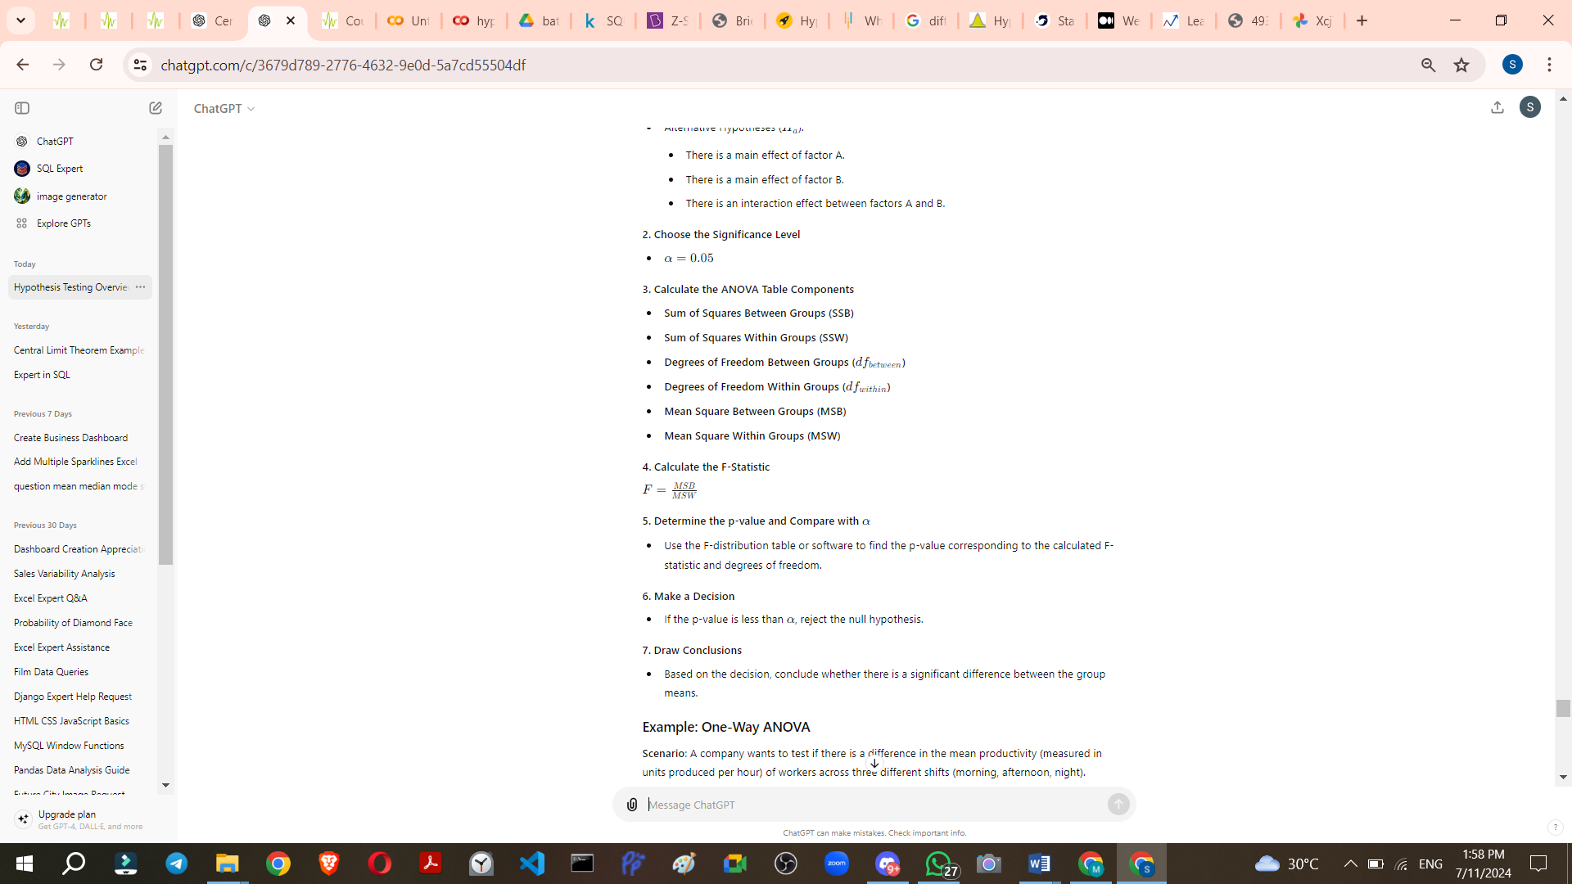

<https://chatgpt.com/share/66f399d8-cb24-8000-b0c1-b8fb00c2179e>

